Sigma Tau Gamma
3.8
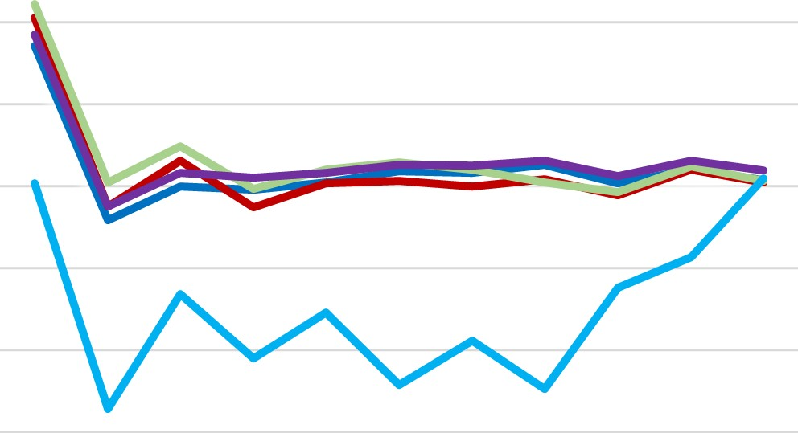
  All Male
  —All IFC
  All Greek
  All Student
   Tau
3.6
3.4
3.2
3
2.8
2.6
2.4

S20 F20 S21 F21 S22 F22 S23 F23 S24 F24 S25

